

Benefits Team 1

March 27, 2023 | Claim Notification Letters Version 1.1

Revision History

| Date | Version | Description | Author |
| --- | --- | --- | --- |
| 3/27/24 | 1.1 | Updated to include other development letters | Jacob Worrell |
| 9/30/22 | 1 | Product Debut | Jacob Worrell |

Table of Contents

1 **Notification Letters Overview**4

2 **User Access** 4

3**Navigation** 4

4 **Functionality** 6

5 **Major Issues and Error Messages** 10

5.1 Subheader (as many as needed) 12

## 1. Product Overview

The Claim Notification Letters tool is currently a feature in the Claims Status Tool, but is often treated as a standalone product. It allows veterans to download decision letters and 5103 Notification letters. In the future, it will contain other claim development letters and appeals decision letters.

## 2. User Access

Users will need to be logged into the site AND have a closed claim on file to have access to notification letters.

## 3. Navigation

**Direct URL: https://va.gov/track-claims/your-claims-letters**

Or, most veterans will likely navigate starting at the VA.gov homepage. They will need to click “chick your claim or appeal status” in the “Disability” section.

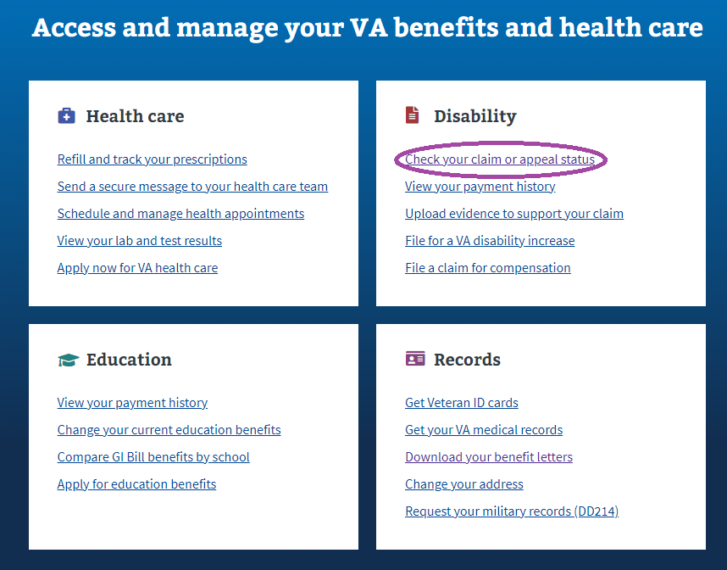

Veterans will then need to click on “View Details” on a claim that is **CLOSED**

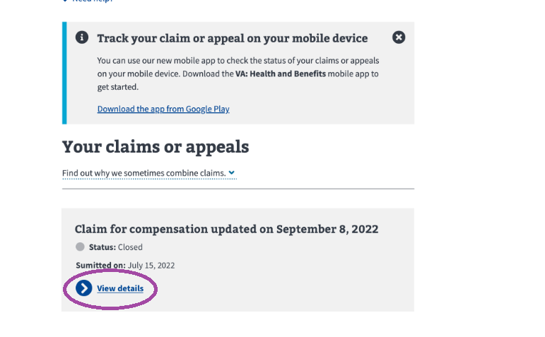

From within a CLOSED claim’s details section, veterans must then click the “Get your claims letters” link.

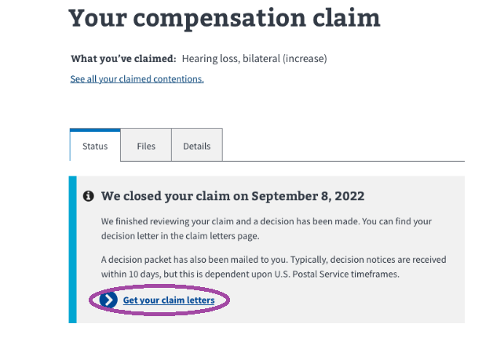

## 4. Functionality

Within the Notification Letters section, a veteran can click on one of the “Download letter” links and download their notification letter.

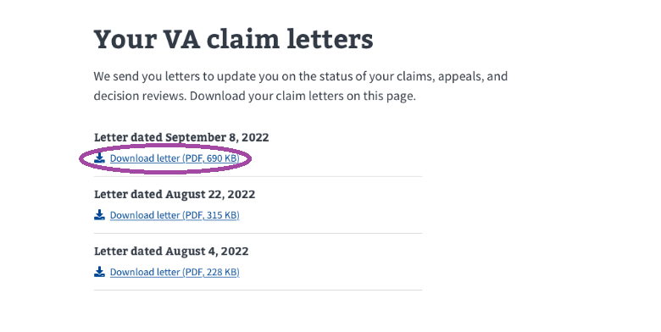

Once a veteran clicks a “Download letter” link, behavior can be browser and user setting specific. The letter will be downloaded immediately or come up as a preview in a browser window.

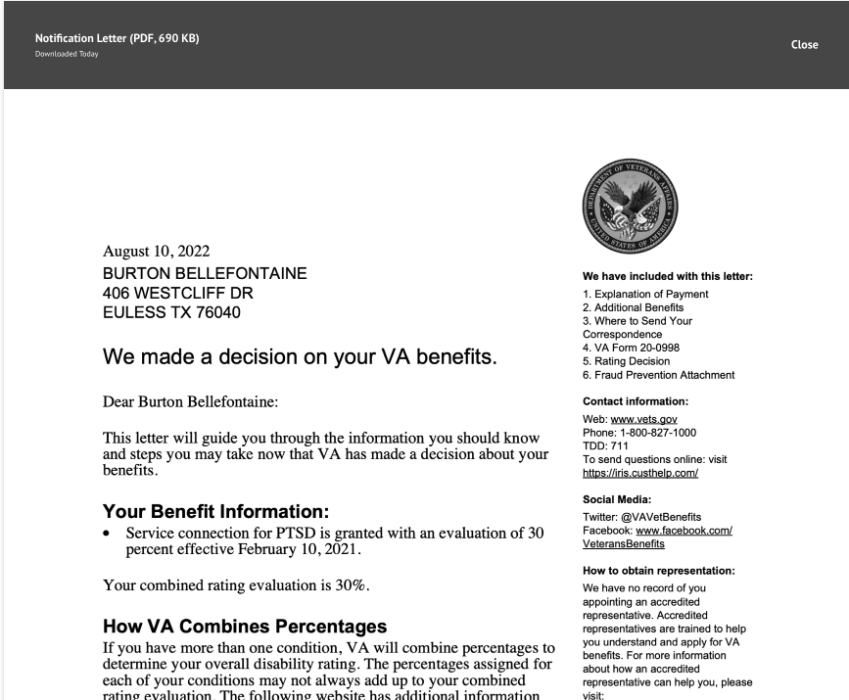

## 5. Major Issues and Error Messages

There are error messages in place for VA maintenance and other service disruptions. In both cases, the user will be notified and asked to check back later.

2